**Py City School Analysis**

Analysis Summary

The analysis is of 15 schools with a total budget of $24,649,428. Out of the districts entire student body 74% of students passed Math and 85% of the students passed Reading. Only 65% of the students in this district passed both Math and Reading. Attached are the overall stats for the district.



We broke out the stats by school. Cabera High School was able to gain the 1 position for students passing reading and math with the 2nd lowest budget per student. There appears to be a negative correlation between school budget and passing grades. Some of the schools with the biggest budget per student have the lowest passing rate. I have attached the top and bottom 5 schools passing Math and Reading

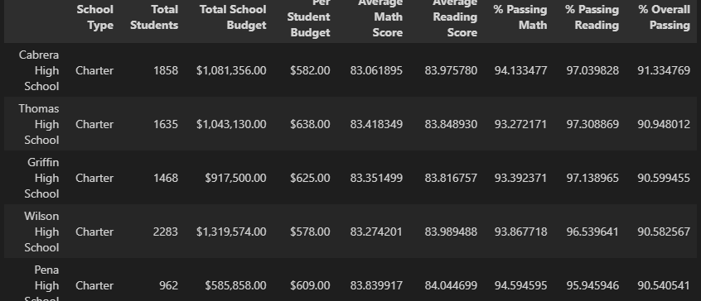

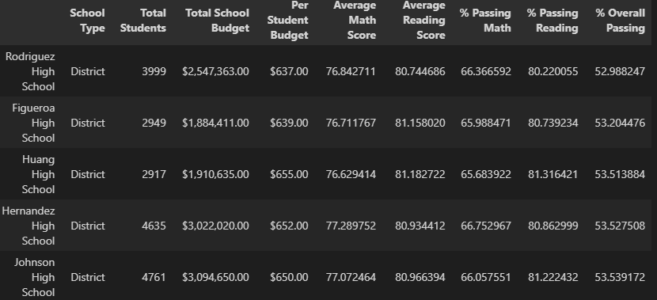

This relationship is better proven by the following chart which groups by Spending Ranges per student. Clearly the schools with a higher overall pass rate have smaller budgets per student.

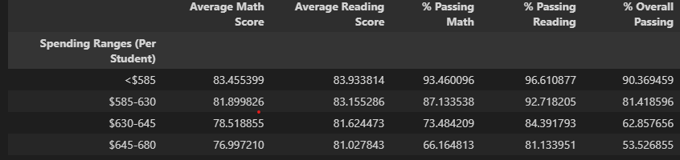

Another Important factor to be considered is the overall size of the school. In this chart we see that the schools with 2000 – 5000 students have a much lower overall pass rate.

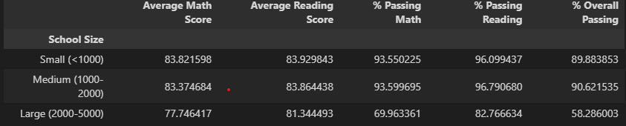

And lastly there is a huge difference in pass rate between Charter and District Schools. 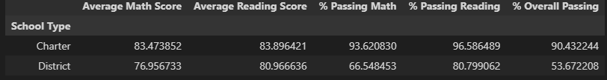

In conclusion if you wanted to pick the best school possible for academics. You would want a school with less then 2000 people and Charter if possible. The budget per student appears to have little impact in some cases there is an inverse relationship. And Charter schools have significantly higher grades.